

RETAINING WALL INSTALLATION GIUDE

*Having the right tools can be a huge time saver during your project. Gather all tools before you begin, so you can avoid unnecessary delays in your project. Here’s a tool checklist to guide you!*

**STEP 1**

**GATHER YOUR TOOLS**

**TOOLS**

* [**Shovel**](https://www.lowes.com/Lawn-Garden-Hand-Tools/Digging-Tools/Shovels-Spades/_/N-1z0wgdo/pl)
* [**Circular Saw**](https://www.lowes.com/Power-Tools/Saws/Circular-Saws/_/N-1z0wckf/pl)
* [**Masonry Circular Saw Blade**](https://www.lowes.com/Saw-Blades/Circular-Saw-Blades-Sets/Circular-Saw-Blades/_/N-1z0wckv/pl)
* [**Chisel**](https://www.lowes.com/Hand-Tools/Chisels-Pry-Bars/Chisels/_/N-1z11pba/pl)
* [**Drilling Hammer**](https://www.lowes.com/Hand-Tools/Hammers-Sledgehammers/Sledgehammers/_/N-1z0ydyp/pl)
* [**Rubber Mallet**](https://www.lowes.com/Tools/Hand-Tools/Hammers-Sledges/_/N-1z11pb1/pl)
* [**Speed Square**](https://www.lowes.com/Tools/Levels-Measuring-Tools/Protractors-Squares/_/N-1z0wcmj/pl)
* [**Tape Measure**](https://www.lowes.com/Tools/Levels-Measuring-Tools/Tape-Measures-Wheels/_/N-1z0wcmg/pl)
* [**Levels**](https://www.lowes.com/Tools/Levels-Measuring-Tools/Levels/_/N-1z0wcmn/pl)
* [**Hand Tamper**](https://www.lowes.com/Outdoor-Tools-Equipment/Axes-Mauls-Log-Splitters/Tampers/_/N-1z0wgf7/pl)
* [**Caulk Gun**](https://www.lowes.com/Paint/Caulking/Caulk-Guns/_/N-1z0yyf7/pl)
* [**Garden Rake**](https://www.lowes.com/Lawn-Garden-Hand-Tools/Rakes-Pitchforks/Garden-Rakes/_/N-1z0wgdz/pl)
* [**Brush**](https://www.lowes.com/Cleaning-Supplies/Cleaning-Tools/Brushes/_/N-1z0w5t2/pl)
* [**Work Gloves**](https://www.lowes.com/Safety/Jobsite-Safety/Work-Gloves/_/N-1z0x595/pl)
* [**Safety Glasses**](https://www.lowes.com/Safety/Jobsite-Safety/Safety-Glasses-Goggles-Face-Shields/_/N-1z0x593/pl)
* [**Hearing Protection**](https://www.lowes.com/Safety/Jobsite-Safety/Hearing-Protection/_/N-1z0x597/pl)
* [**Respirator / Dust Mask**](https://www.lowes.com/Safety/Jobsite-Safety/Safety-Masks/_/N-1z0x59b/pl)
* [**Back Support**](https://www.lowes.com/Tools/Tool-Storage-Work-Benches/Tool-Belts-Accessories/_/N-1z0yht3/pl)

**Materials**

* [**Interlocking Retaining Wall Blocks**](https://www.lowes.com/Pavers-Retaining-Walls/Retaining-Walls/Retaining-Wall-Block/_/N-1z0wga9/pl)
* [**Landscape Fabric**](https://www.lowes.com/Fertilizer-Weed-Control/Weed-Control/Landscape-Fabric/_/N-1z0wgi1/pl)
* [**Gravel / Drainage Aggregate**](https://www.lowes.com/Outdoors/Mulch-Rock-Soil/Rock/_/N-1z0wgfj/pl)
* [**Construction Adhesive**](https://www.lowes.com/Glues-Tapes/Glues/Construction-Adhesive/_/N-1z0s9o0/pl)
* [**Paver Base**](https://www.lowes.com/Pavers-Retaining-Walls/Stones-Pavers/Paver-Base-Leveling-Sand/_/N-1z0wga4/pl)
* [**Mason Line**](https://www.lowes.com/Hardware/Chains-Ropes-Tie-Downs/String-Twine/_/N-1z0zahj/pl)
* [**Landscape Stakes**](https://www.lowes.com/Fertilizer-Weed-Control/Weed-Control/Landscape-Stakes/_/N-1z0wghz/pl)
* [**Marking Paint**](https://www.lowes.com/Paint/Paint-Primer/Spray-Paint/_/N-1z0yrgbZ1z0vbx1/pl)
* [**Garden Soil**](https://www.lowes.com/Outdoors/Mulch-Rock-Soil/Soil/_/N-1z0wgft/pl)
* [**Retaining Wall Caps (Optional)**](https://www.lowes.com/Pavers-Retaining-Walls/Retaining-Walls/Retaining-Wall-Block/_/N-1z0wga9Z1z0yy3e/pl)
* [**Hose (Optional)**](https://www.lowes.com/Watering-Irrigation/Garden-Hoses-Accessories/Garden-Hoses/_/N-1z0wg6x/pl)
* [**Rope (Optional)**](https://www.lowes.com/Packaged-Rope/_/N-1z11olo/pl)

***Simply call 811 from your phone and they will ask you a series of questions to get the ball rolling. Georgia 811 will tell you when it is safe to start digging. This usually takes around 3-4 days.***



RETAINING WALL INSTALLATION GIUDE

**STEP 2**

Generally, if a wall is above 4’ tall you need a building permit and for walls over 6’ you need a building permit as well as an engineered drawing. So before you buy materials or begin work, check your local building codes and your homeowner's association regulations to see if there are any restrictions or requirements you need to follow.

Plan your layout. Avoid having downspouts pointed at the retaining wall and, if it's against the house, keep soil and mulch well below the siding.

Your retaining wall design will determine how you mark the area. To mark a freeform layout, use a rope or hose to outline the shape. Then use a shovel to mark the outline. For straight lines, mark the entire bed area with stakes and string. You can also use marking paint to mark the wall.

Now that you have designed your wall, it’s time **TO START DIGGING!!**

**PLANNING YOUR WALL**

**STEP 3**

* This is the MOST important part of the wall. A wall that has proper base will last forever. A wall that does not will have to be fixed eventually.
* Start with your trench. Your trench should be 2’ wide and 10” deep (if using 6” thick block) or 12” deep (if your using 8” thick block) One block should be totally buried.
* If the trench slopes, you'll have to step up or down to keep the blocks level. Use a torpedo level to create steps so that each section of the wall remains level.
* Tamp down the dirt with a hand tamper or gas plate compactor and keep it level.
* 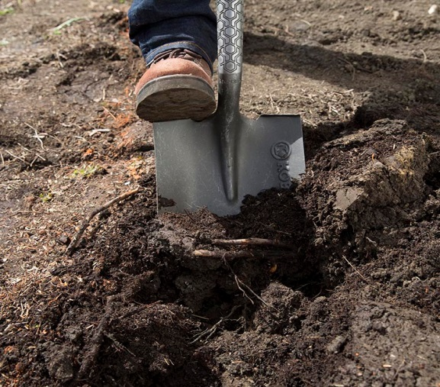Fill the trench with about 4” inches of crusher run, spread it with a rake, and tamp it down. Tamping the base provides a strong foundation. Take your time leveling the area and get is as level as possible. The more level this area is the easier laying the base course will be. Now it’s time to start installing the blocks.

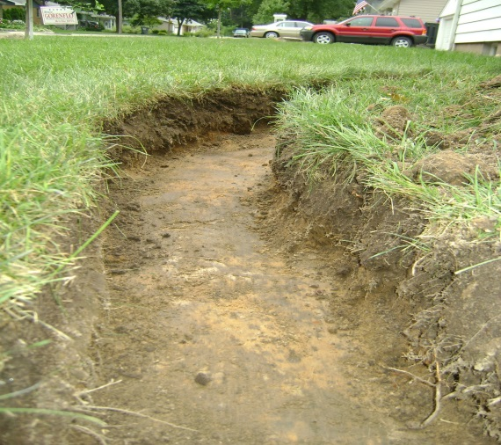

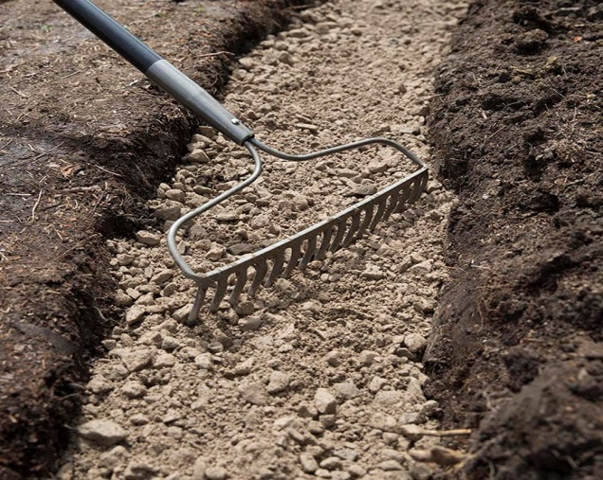

**PREPARING YOUR FOUNDATION**

RETAINING WALL INSTALLATION GIUDE

* For row one, knock the lip on that back of the block off with a hammer and chisel if needed so the blocks will sit flat.

**STEP 4**

**INSTALLING YOUR WALL**

* Beginning at the end with the lowest elevation, set the first block in place and check for level side-to-side and front-to-back
* 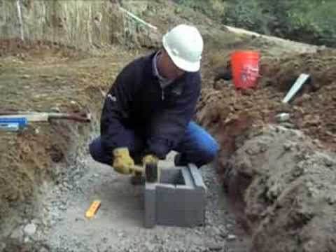
* From here drive a stake in the ground at the side of the block. Tie a string around it and run the string along the line the blocks should take. Drive a stake into the other end and tie the string there too. Use the string as a guide for the face of the blocks. Doing this will keep your wall straight.
* Place the next block, making sure it's even with the first. Continue installing the first row, periodically checking for level.
* To level the rows and keep the blocks even, fill in under low blocks with paver base or tap down high blocks with a rubber mallet.
* After installing each row, sweep dirt off the tops. If your using hollow core blocks, fill the voids with #57 granite after each course you lay.
* To start the second row you’ll have to cut or break a block to stagger the joints. Mark it, and cut it with a masonry blade or we can use our block breaker to help you with this.
* Put the half block in place, keeping the lip tight against the first row. Check it for level.
* After installing this row, you'll need to add drainage directly behind the blocks. Lay down landscape fabric behind the wall, starting from behind base of wall and drape over the dirt. This fabric should be able to reach up to the top of your finished wall.
* Fill behind the wall to up to only ground level. At ground level, you will install your drainage pipe. This should be a sock pipe (perforated pipe with a fabric sleeve). Lay the pipe behind the entire wall. Water will seep into this, so make sure you have an exit point for the pipe at end of wall.

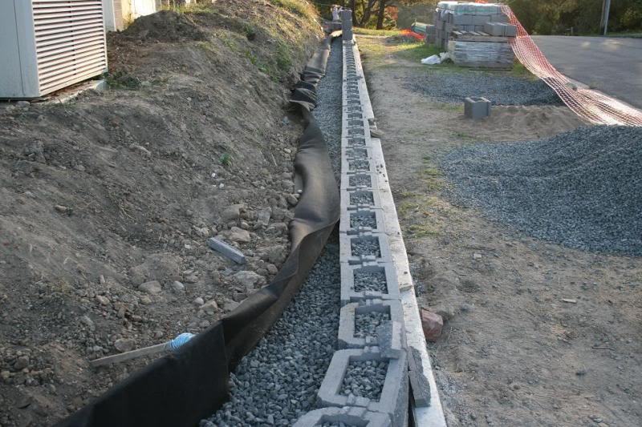

* If your wall is long, then you will have to use a 4” drainage tee to pop out of the wall every 50ft.
* Fill in directly behind the wall with gravel, and then continue to build by adding more rows.
* Fill your drainage up as you go as well as your dirt. Compacting the dirt as layer by layer will give you the best compaction.
* Fill behind wall with gravel until you get about half way up the last block.
* Fold the excess fabric back over the gravel to cover it completely

**Finishing**

* Once you’ve completed the final course, it’s time to put the caps pieces on.

RETAINING WALL INSTALLATION GIUDE

* The caps can be secured down with a couple beads of construction adhesive.
* You can either choose to overhang your block with the cap or set it flush with the edge. This is more of a preference and either way works.
* If your wall is straight the caps should go really quick, but if you have some curves it will require some cutting.
* To cut the caps you will need a diamond blade on a concrete saw or circular saw.
* You can measure the caps for the cuts or use the installed caps as a guide

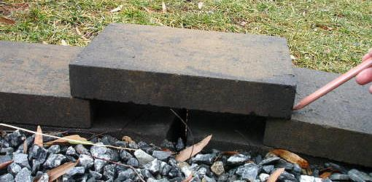

* **You’re finished!!**